**How to get the OAuth Token for the Fitbit API**

Here I have used the implicit code flow for my project.

**Steps:**

1. Go to <https://dev.fitbit.com/apps> and Login
2. Register a new app

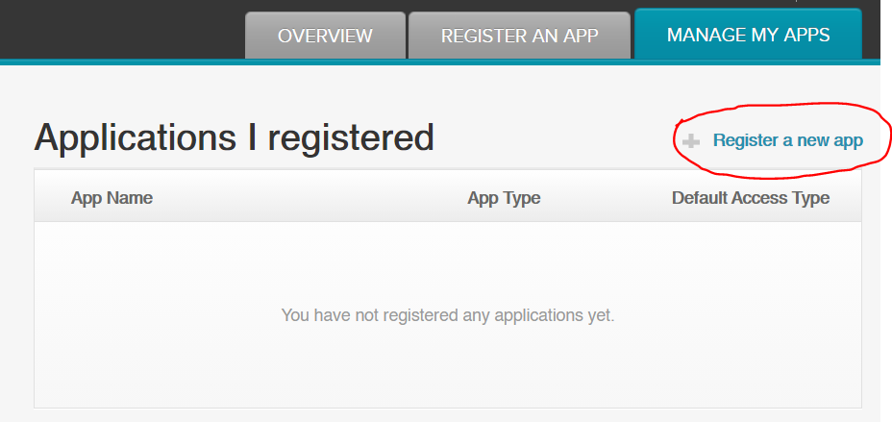

1. Fill up the fields

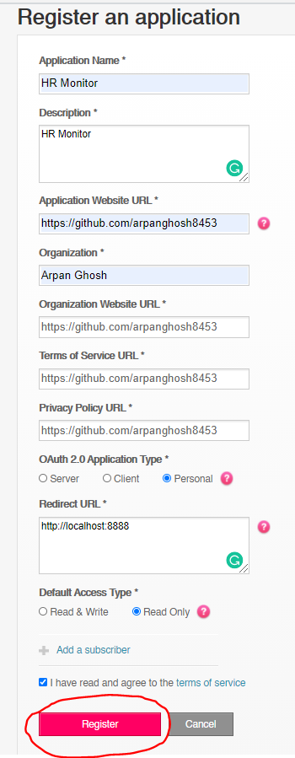

1. Click on the OAuth tutorial page

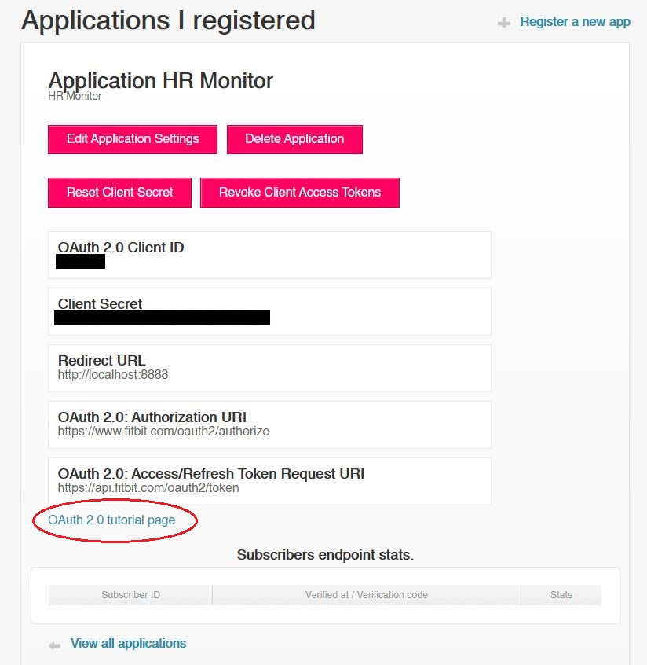

1. Choose the Implicit Grant flow and Click on the link below there

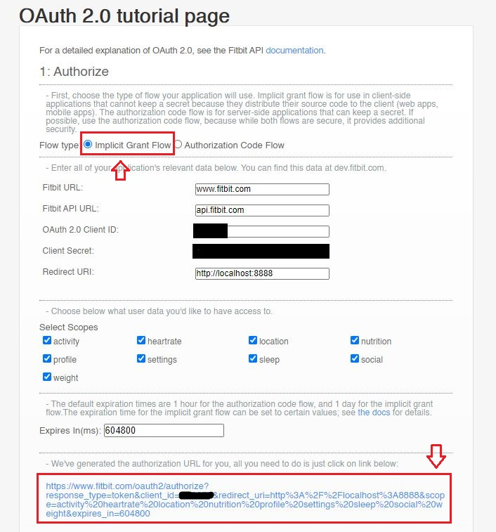

1. Grand the Access from the page opened.

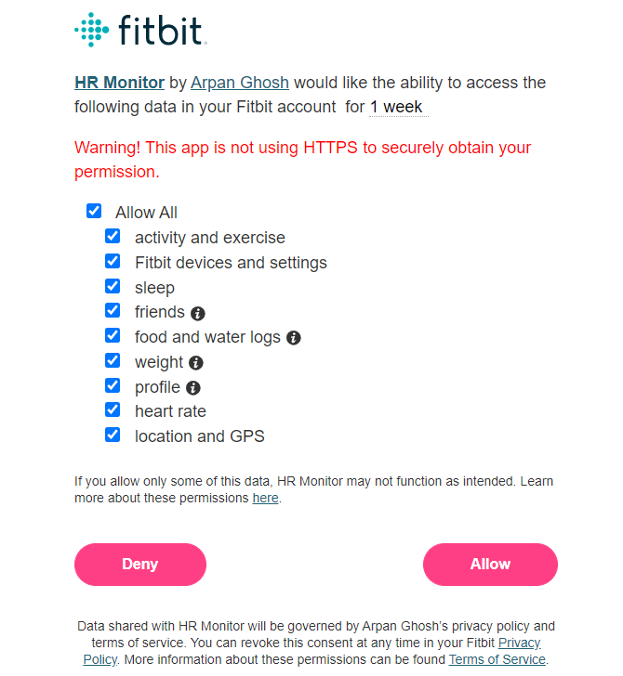

1. Click on allow and it will say the page cannot be reached. That’s fine. Just see the change in url and copy everything from the resulting url (after you click allow) after the # symbol and put them in the next field (Parse response) of the page.

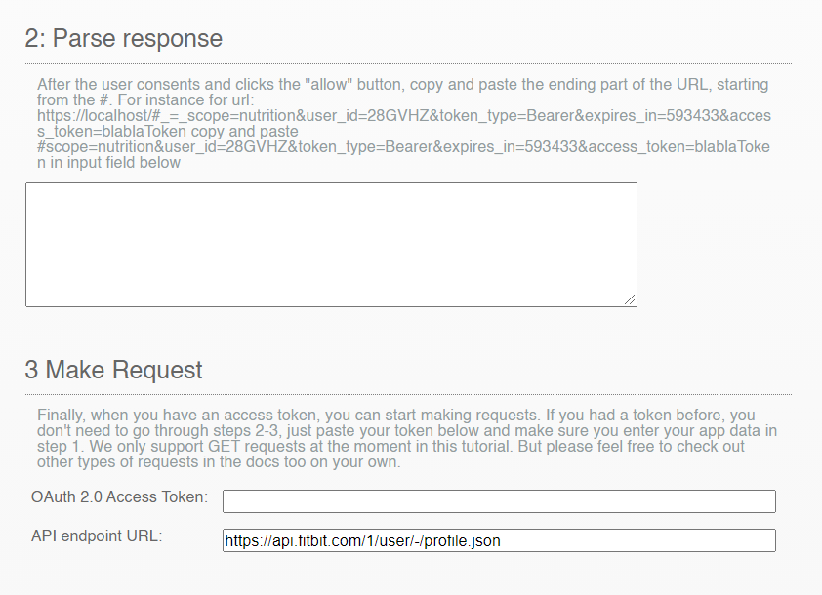

1. It will show you the granted Auth Token there and you can replace the token part of the code with the granted token shown here. I am not including a screenshot of the page due to security reasons.